|  |
| --- |
| User Manual  Leave Approval(HRM & DM) |
| REFERENCE: GW/ERP/USER MANUAL |
|  |
| **Genweb2 Ltd.** |
| **10-Jul-17** |



|  |
| --- |
|  |

Contents

1. Leave Request Approval by Department Manager 3

1.1 Leave Summary 3

1.2 First Approval Leave Request by Department manager 3

2. Second Leave Request Approval by Next Hierarchy Manager 6

2.1 Leave Summary 6

2.2 Second Approval Leave Request by Respective Manager 6

3. Final Leave Request Approval by HR Manager 7

3.1 Leave Summary 7

3.2 Final Approval Leave Request by HR Manager 8

4. Leave Allocation Request Approval by Department Manager 8

4.1 First Approval Leave Allocation Request by Department Manager 8

5. Leave Allocation Request Approval by HR Manager 9

5.1 Final Approval Leave Allocation Request by HR Manager 9

6. Manual Attendance Request Approval by Department Manager 10

6.1 Pending Manual Attendance 10

6.2 Approval Manual Attendance Request by Department manager 10

# 1. Leave Request Approval by Department Manager

## 1.1 Leave Summary

Only approver hierarchy user can see all of employee leave Summary/Leave allocation/Leave request, if He/she exist in set custom chain level. Which will set to employee profile form.

Using the menu **Leave ‣ My Leaves ‣ Leave Summary**.

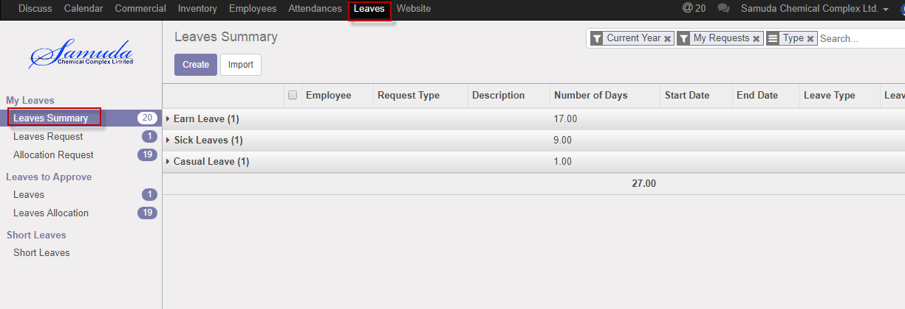

Figure: Leave Summary

## 1.2 First Approval Leave Request by Department manager

After apply the leave request “Respective department manager” will get the notification. Respective Manager Can first/final approve the leave request. That’s approve will final approve if no other employee none the set custom chain. Respective Management can update number of leave day(s) before approve. After department Manager Approval, Next hierarchy user will get notification. s

To see the employee leave request use the menu **Leave ‣ My Leaves ‣ Leaves Request.**

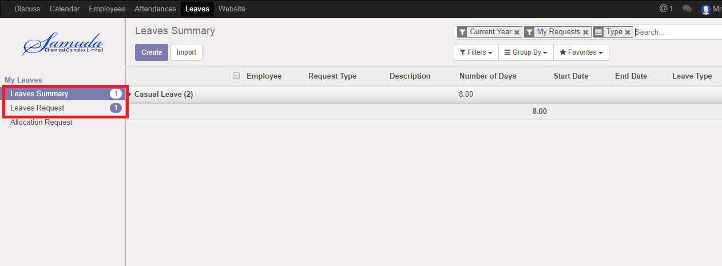

Figure: Leave Request Notification

Department manager can approve employee’s leave request. Department Manager can see all leave request there **Leave ‣ Leave to approve ‣ Leaves.**

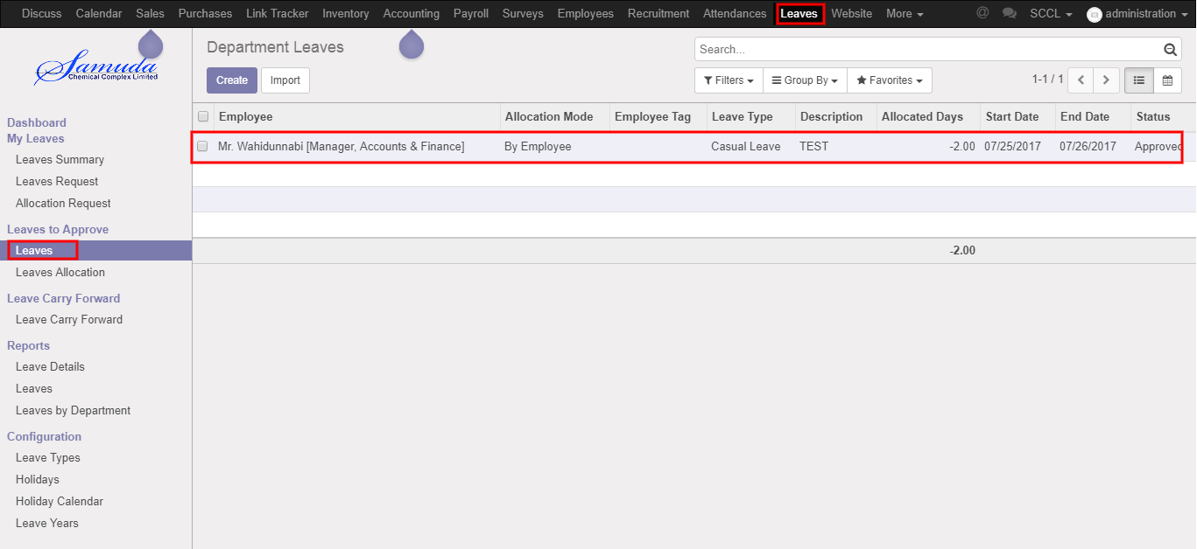

Figure: Leave Request List View

Here Department Manager can first approve the leave request by click on **Approve** button. He can update number of leave day(s) before approval.

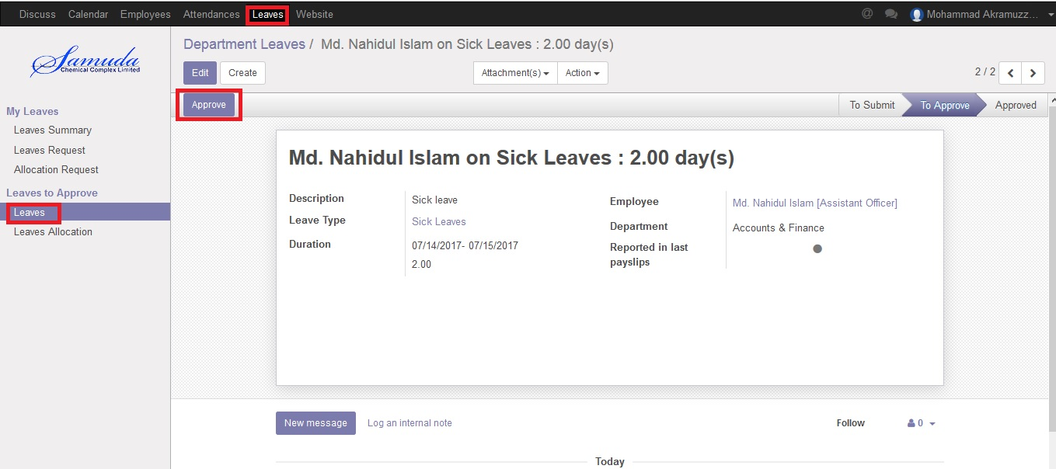

Figure: A Leave Request First Approval

Department Manager can refuse leave request by click **Refuse** Button.

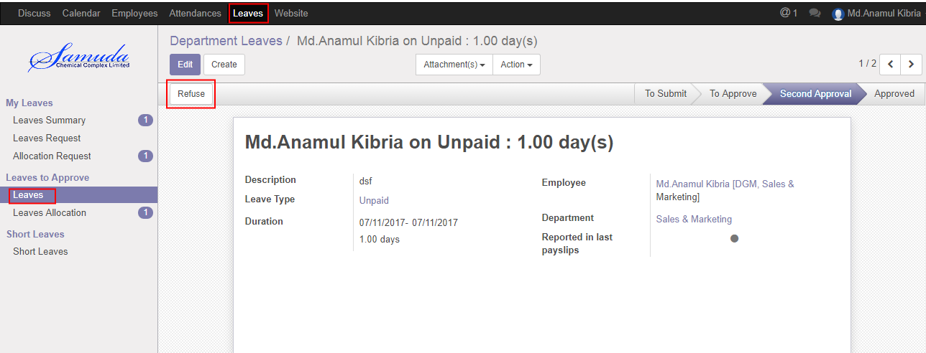

Figure: A Leave Request Refuse

# 2. Second Leave Request Approval by Next Hierarchy Manager

## 2.1 Leave Summary

Respective Manager can see all of employee leave Summary.

Using the menu **Leave ‣ My Leaves ‣ Leave Summary**.

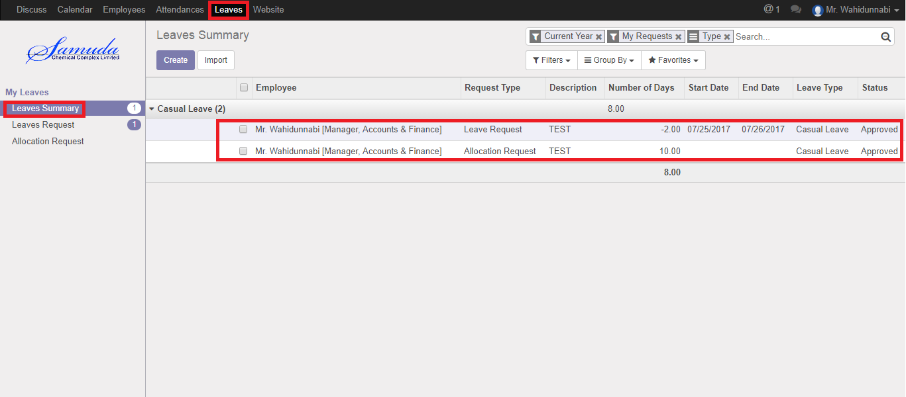

Figure: Leave Summary

## 2.2 Second Approval Leave Request by Respective Manager

After first approval, respective manager can second/final approve or refuse the employee’s leave request. Manager can see all leave request there **Leave ‣ Leave to approve ‣ Leaves.**

Here respective Manager can second approve the leave request by click on **Approve** button. He can update number of leave day(s) before approval. That’s the way leave will approve hierarchy wise one after another.

Respective manager can refuse leave request by click **Refuse** Button

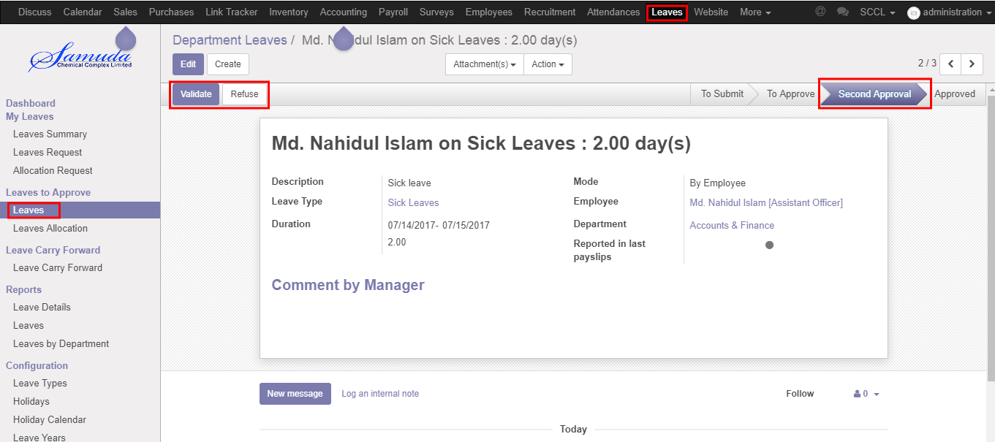

Figure: A Leave Request Second Approval

# 3. Final Leave Request Approval by HR Manager

## 3.1 Leave Summary

HR Manager can see all of employee leave Summary. Using the menu **Leave ‣ My Leaves ‣ Leave Summary**. 

Figure: Leave Summary

## 3.2 Final Approval Leave Request by HR Manager

After Second approval, respective manager can final approve or refuse the employee’s leave request. HR Manager can see all leave request there **Leave ‣ Leave to approve ‣ Leaves.**

Here HR Manager Can final approve the leave request by click on **Validate** button.



Figure: A Leave Request final Approval

# 4. Leave Allocation Request Approval by Department Manager

## 4.1 First Approval Leave Allocation Request by Department Manager

After apply the leave allocation request “Department Manager” will get the notification. Department Management can update number of leave day(s) before approval. After Department Manager Approval, HR will get notification.

Here Department Manager can first approve the leave allocation request by click on **Approve** button.

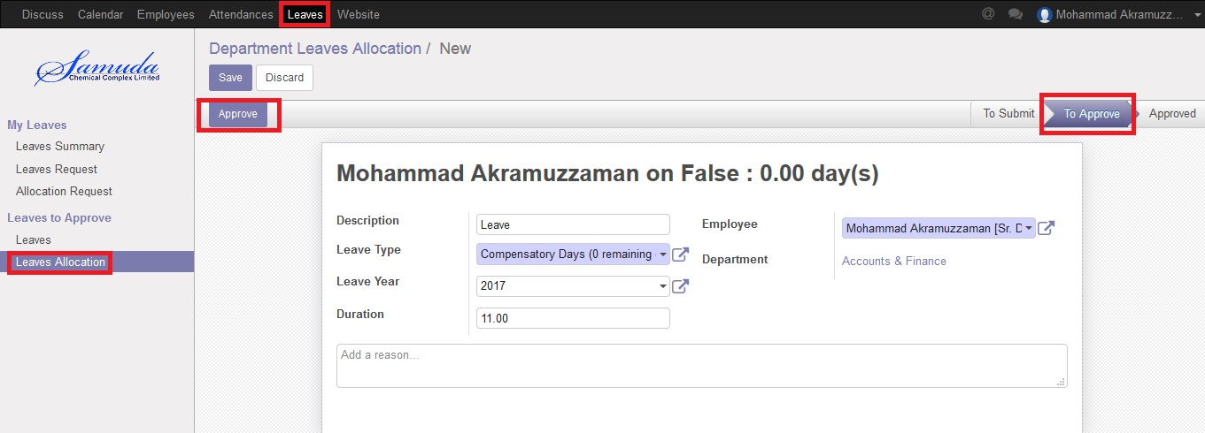

Figure: Leave Allocation Request First Approval

# 5. Leave Allocation Request Approval by HR Manager

## 5.1 Final Approval Leave Allocation Request by HR Manager

After apply the leave allocation request “HR Manager” will get the notification. After first approval the leave allocation request by Department Manager, HR Manager will get notification. HR Manager Can Approve or Refuse the leave allocation request. After that requested leave will finally approve.

Allocation approval process also like leave request process & hierarchy wise allocation will approve.

Here HR Manager Can final approve the leave request by click on **Validate** button.

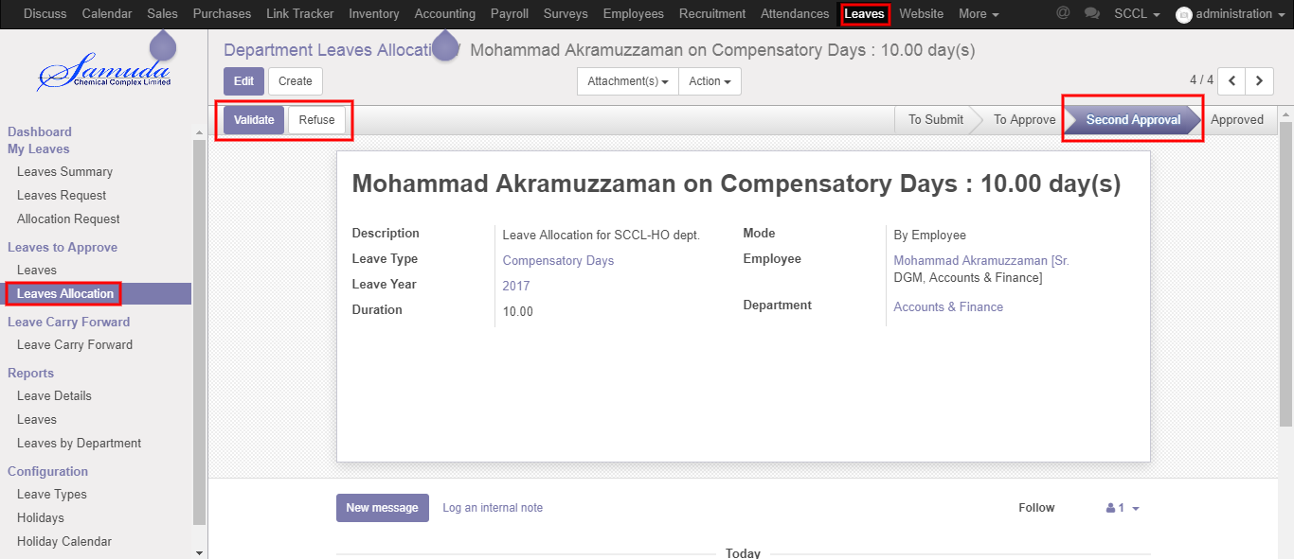

Figure: Leave Allocation Request final Approval

# 6. Manual Attendance Request Approval by Department Manager

## 6.1 Pending Manual Attendance

Department manager can see all of employee pending manual attendance request.

Using the menu **Attendance ‣ Pending Approvals**.

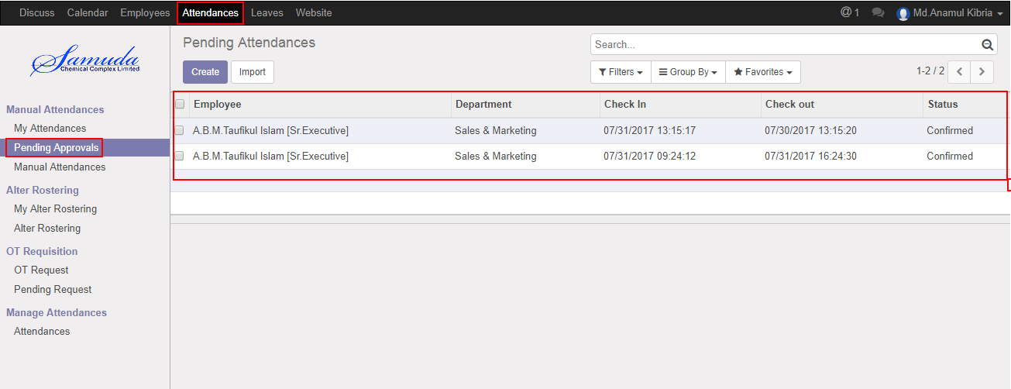

Figure: Manual Attendance Pending Approval List View

## 6.2 Approval Manual Attendance Request by Department manager

After apply the manual attendance request “Department Manager” will get the notification. Department Manager can approve the manual attendance request.

To see the employee manual leave request use the menu **Attendance ‣ Pending Approvals**. Here Department Manager can first approve the manual attendance request by click on **Approve** button.

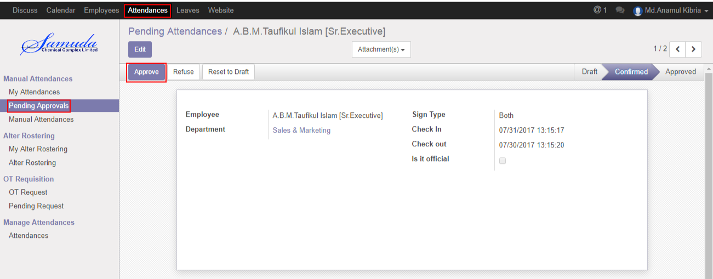

Figure: Manual Attendance Request Approval

Department Manager can refuse manual attendance request by click **Refuse** Button.

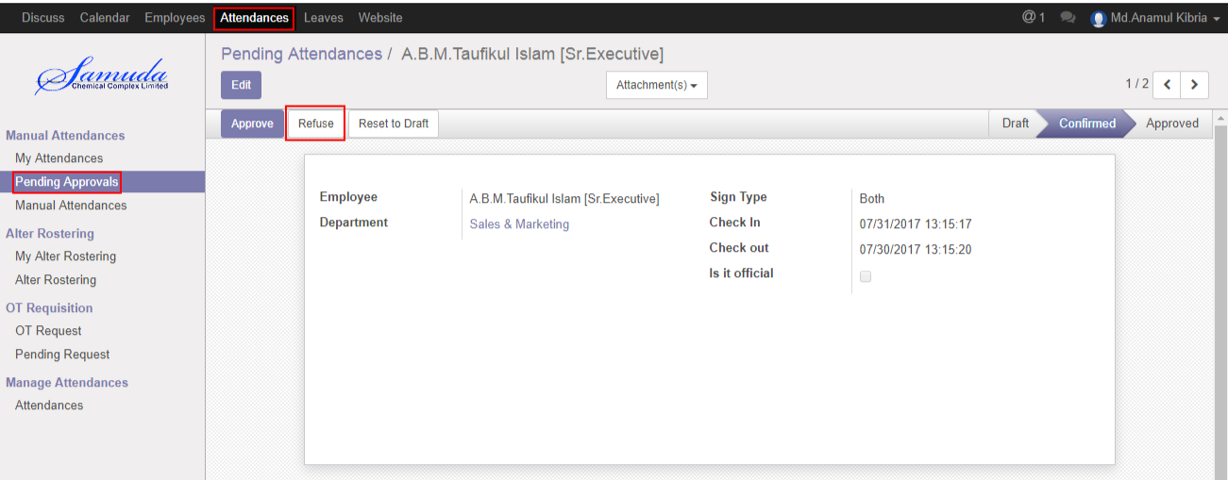

Figure: A Manual Attendance Request Refuse